Activity or Task: |  |  |  |  |  |  |  | Date:
Completed By: |  |  |  |  |  |  |  | Date:
Work Steps and Tasks  Describe the tasks / steps involved in the work – in order |  | Hazards Identified for each Task / Step |  | Risk Level  Use Risk Assessment Table (page 2) |  | Control / Safe Work Procedures for each Task / Step  Controls to be implemented (consider the hierarchy of hazard controls – page 3)
e.g. Painting commercial building facia |  | Powerlines in close proximity to scaffold |  | E9 |  | Energy company advised and contracted to de-energise or redirect power away from the identified lines and fit tiger tails.
Hazards Checklist
- Can someone be struck or contacted by anything while doing this job? |  |  | - Can someone slip, trip or fall? |  |  |  | - Can someone fall into any thing?
- Can someone strike against or make contact with any physical hazards? |  |  | - Can someone strain or overexert? |  |  |  | - Can damage to equipment occur?
- Can someone be exposed to any hazardous conditions? |  |  | - Can someone be caught in anything? |  |  |  | - Can someone injure someone else?
Safety Officers/Mangers/supervisors Comments |  |  |  |  |  | Date:
 |  |  |  |  |  | Employees Signature:

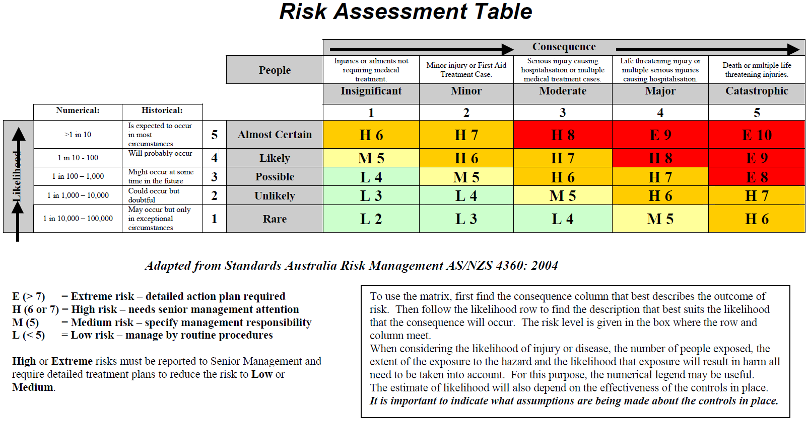

HIERARCHY OF HAZARD CONTROLS

In many cases a range of control methods must be used to control hazards. This page lists various strategies to be considered in order of preference. It is known as the hierarchy of hazard controls.

The emphasis is on controlling the hazard at the source. This is done by giving preference to the use of the ‘engineering controls’ outlined in strategies 1 to 5.

These types of strategies should be used, where possible, because they are less subject to human failure and because they are less disruptive and uncomfortable for people working in the area.

Whichever methods you use, remember that in each case their effectiveness should be monitored regularly.

Engineering Controls

1. DESIGN. Try to ensure that hazards are ‘designed out’ when new materials, equipment and work systems are planned for the workplace

2. REMOVE the hazard or SUBSTITUTE less hazardous materials, equipment or substances

3. ADOPT A SAFER PROCESS. Alterations to tools, equipment or work systems can often make them much safer

4. ENCLOSE OR ISOLATE THE HAZARD through the use of guards or remote handling techniques

5. PROVIDE EFFECTIVE VENTILATION through local or general exhaust ventilation systems

Administrative Controls

6. ESTABLISH appropriate ADMINISTRATIVE PROCEDURES such as:

• job rotation to reduce exposure or boredom; or timing the job so that fewer workers are exposed

• routine maintenance and housekeeping procedures

• training on hazards and correct work procedures

Personal Protective Equipment

7. PROVIDE suitable and properly maintained PERSONAL PROTECTIVE EQUIPMENT and training in its use

