[Your business name]
[& Business Details]
We follow and recommend all employees and subcontractors follow the up-to-date guidelines provided at https://www.health.gov.au/health-topics/novel-coronavirus-2019- ncov
Our staff will supply facilities for hand washing, liquid soap and antibacterial products and disposable hand towels plus a thermometer available to staff and designate a person to carry out all these duties.
Our policy is aimed at preventing the spread of the virus, and is as follows:
- If you are unwell with any symptoms such as fever (high temperature), cough, sore throat or shortness of breath (finding it hard to breathe)– please contact your supervisor immediately and do not attend work. If at work, leave immediately and seek medical advice. Do not return to work until you have been given the all clear from your doctor (you may need to provide a medical certificate). If you do stay home from work, it is recommended that you remain in your residence and restrict activities outside of your home, except for receiving medical care. Please do not return to work, until you have been given the all clear from your doctor.

- If you, or a family member, that resides with you have travelled overseas within the last 14 days, it is advised that you do not return to work until after 14 days of being back in Australia, and only if you have not developed any of the COVID-19 symptoms listed above. If you have these symptoms, you should seek medical advice.

- If you have been in contact with a person who has been infected with COVID-19 within the last 14 days, it is advised that you do not return to work until after 14 days of exposure to that affected person, and only if you have not developed any of the COVID- 19 symptoms listed above. If you know that you have been in contact with someone who has been infected with COVID-19, you should seek medical advice until your doctor has given you the all clear.

- Notify your employer or team leader if you may have been exposed to someone with COVID-19

- While you are on site, you must wash your hands well and often, as per the following guidelines that have been provided and were developed by the World Health Organisation https://www.who.int/gpsc/clean_hands_protection/en/.
A copy of this procedure is included.

- Practice good sneeze and cough etiquette including coughing and sneezing into your elbow or a clean tissue, which you will safely dispose of.

- Wash your hands immediately, do not touch any surfaces.

- Do not shake hands.

- Avoid touching your eyes, nose and mouth with unwashed hands.

- Keep at least 1.5 metres away from people who are coughing/showing signs of illness.

Clean hands protect against infection

Protect yourself
- Wash your hands regularly.
- Wash your hands with soap and water, and dry them thoroughly.
- Use alcohol-based hand rub if you don’t have immediate access to soap and water.

How do I wash my hands properly?
Washing your hands properly takes about as long as singing "Happy Birthday" twice,
using the images below.
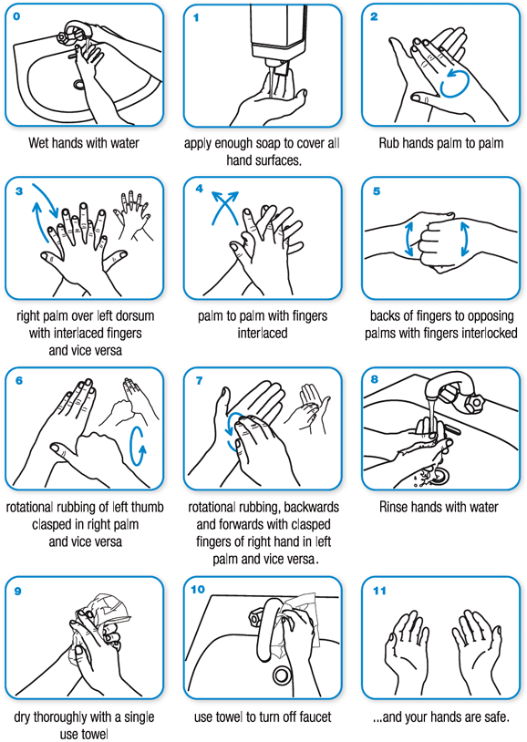

COURTESY OF THE WORLD HEALTH ORGANISATION
EMPLOYEE DIRECYTIVE SUMMARY COVID-19
- Take your temperature before reporting to work, temperature must be under 38°C
- Confirm no symptoms of illness such as, cough, sore throat or shortness of breath
- Do not report to work if you have a fever (high temperature) or other symptoms are present
- Contact your employer or team leader immediately if unable to report to work
- Self-isolate for 14 days, and seek medical advice
- Notify your employer or team leader if you have knowingly had exposure to someone with COVID-19
- Notify your employer or team leader if you believe you may have exposed someone to COVID-19
HOW TO CHECK YOUR BODY TEMPERATURE USING A THERMOMETER
What is a normal body temperature?
The normal range for the human body temperature is between 36°C and 38°C. however, it is usual to consider a reading above 37.2°C as suspicious. Repeated checks should be done to confirm.
A person’s temperature can change due to hormonal changes, exposure to heat or cold, exercise, and infection.
What will you need?
You will need the following items to conduct the test:
- A thermometer, please refer to the instructions for your individual thermometer type.
- Record chart/or note pad and a pen
Preparation
- Wash and dry your hands as this will prevent cross infection.
- The person conducting the test shall explain to the person being tested what the procedure entails and ensures they understand, this will make it easier for them to co-operate.
- Ensure that you follow the cleaning procedures of the individual thermometer as per the thermometers instructions.
- Ensure thermometers are thoroughly sanitised prior to using on another person.

Testing method
- Use the testing methods for your individual thermometer type.
- Read, and immediately record the temperature on the record chart or in the note pad.
- Tell the person being tested their temperature and whether any further investigations are required.
- Sanitize the thermometer as per its instructions.
- Report a raised temperature to the authorised person in charge.
- Sanitize the thermometer as per its instructions.
- Quarantine the person in an area away from others immediately
- Seek advice on next step.

